Experiment No 6

Title Implement following 2D transformations on the object with respect to axis : i) Scaling ii) Rotation about arbitrary point iii) Reflection

Translation: Translation is defined as moving the object from one position to

another position along

straight line path.

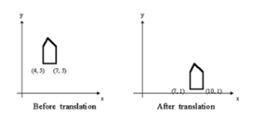

We can move the objects based on translation distances along x and y axis. tx denotes

translation distance along x-axis and ty denotes translation distance along y axis.

Translation Distance: It is nothing but by how much units we should shift the object from one

location to another along x, y-axis.

Consider (x,y) are old coordinates of a point. Then the new coordinates of that same point

(x’,y’) can be obtained as follows:

X’=x+tx

Y’=y+ty

Scaling: scaling refers to changing the size of the object either by increasing or decreasing.

We will increase or decrease the size of the object based on scaling factors along x and y -

axis.

If (x, y) are old coordinates of object, then new coordinates of object after applying scaling

transformation are obtained as:

x’=x*sx

y’=y*sy.

sx and sy are scaling factors along x-axis and y-axis. we express the above equations in

matrix form as:

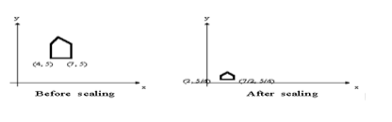

Rotation : A rotation repositions all points in an object along a circular path in the plane

centered at the

pivot point. We rotate an object by an angle theta

New coordinates after rotation depend on both x and y

x’ = xcosθ -y sinθ

y’ = xsinθ+ ycosθ

or in matrix form:

P' = R • P,

R-rotation matrix.

Formula: X = xcosA - ysinA

Y = xsinA + ycosA,

A is the angle of rotation.

The above formula will rotate the point around the origin.

To rotate around a different point, the formula:

X = cx + (x-cx)*cosA - (y-cy)*sinA,

Y = cx + (x-cx)*sinA + (y-cy)*cosA,

cx, cy is centre coordinates,

A is the angle of rotation.

The OpenGL function is glRotatef (A, x, y, z).

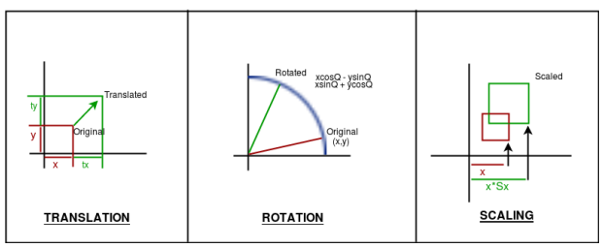

Reflection: It is a transformation which produces a mirror image of an object. The mirror

image can be either about x-axis or y-axis. The object is rotated by180°.

Types of Reflection:

1. Reflection about the x-axis

2. Reflection about the y-axis

3. Reflection about an axis perpendicular to xy plane and passing through the origin

4. Reflection about line y=x

1. Reflection about x-axis: The object can be reflected about x-axis with the help of the

following matrix

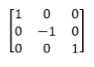

In this transformation value of x will remain same whereas the value of y will become

negative. Following figures shows the reflection of the object axis. The object will lie

another side of the x-axis.

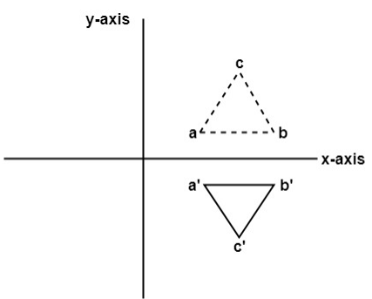

2. Reflection about y-axis: The object can be reflected about y-axis with the help of

following transformation matrix

Here the values of x will be reversed, whereas the value of y will remain the same. The

object will lie another side of the y-axis.

The following figure shows the reflection about the y-axis

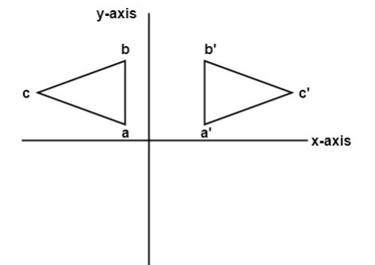

3. Reflection about an axis perpendicular to xy plane and passing through origin:

In the matrix of this transformation is given below

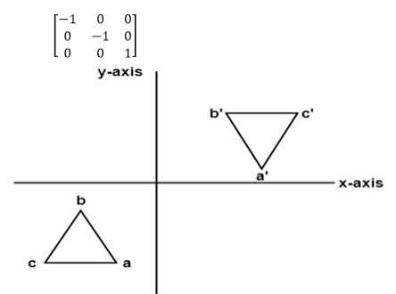

In this value of x and y both will be reversed. This is also called as half revolution about the

origin.

4. Reflection about line y=x: The object may be reflected about line y = x with the help of

following transformation matrix

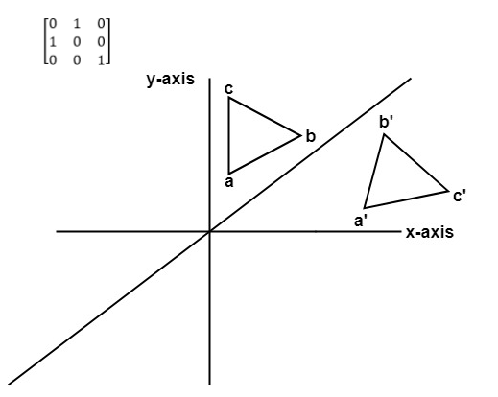

First of all, the object is rotated at 45°. The direction of rotation is clockwise. After it

reflection is done concerning x-axis. The last step is the rotation of y=x back to its original

position that is counterclockwise at 45°.

Example: A triangle ABC is given. The coordinates of A, B, C are given as

A (3 4)

B (6 4)

C (4 8)

Find reflected position of triangle i.e., to the x-axis

#include <iostream>

#include <math.h>

#include <time.h>

#include <GL/glut.h>

#include <vector>

using namespace std;

int edge;

vector<int> xpoint;

vector<int> ypoint;

int ch;

double round(double d){

return floor(d + 0.5);

}

void init(){

glClearColor(1.0,1.0,1.0,0.0);

glMatrixMode(GL_PROJECTION);

gluOrtho2D(0,640,0,480);

glClear(GL_COLOR_BUFFER_BIT);

}

void translation(){

int tx, ty;

cout<<"\t Enter Tx, Ty \n";

cin>> tx>> ty;

//Translate the point

for(int i=0;i<edge;i++){

xpoint[i] = xpoint[i] + tx;

ypoint[i] = ypoint[i] + ty;

}

glBegin(GL_POLYGON);

glColor3f(0,0,1);

for(int i=0;i<edge;i++){

glVertex2i(xpoint[i],ypoint[i]);

}

glEnd();

glFlush();

}

void rotaion(){

int cx, cy;

cout<<"\n Enter Ar point x , y ";

cin >> cx >> cy;

cx = cx+320;

cy = cy+240;

glColor3f(0.0, 1.0, 0.0);

glBegin(GL_POINTS);

glVertex2i(cx,cy);

glEnd();

glFlush();

double the;

cout<<"\n Enter thetha ";

cin>>the;

the = the * 3.14/180;

glColor3f(0,0,1.0);

glBegin(GL_POLYGON);

for(int i=0;i<edge;i++){

glVertex2i(round(((xpoint[i] - cx)*cos(the) - ((ypoint[i]-cy)*sin(the))) + cx),

round(((xpoint[i] - cx)*sin(the) + ((ypoint[i]-cy)*cos(the))) + cy));

}

glEnd();

glFlush();

}

void scale(){

glColor3f(1.0,0,0);

glBegin(GL_POLYGON);

for(int i=0;i<edge;i++){

glVertex2i(xpoint[i]-320,ypoint[i]-240);

}

glEnd();

glFlush();

cout<<"\n\tIn Scaling whole screen is 1st Qudrant \n";

int sx, sy;

cout<<"\t Enter sx, sy \n";

cin>> sx>> sy;

//scale the point

for(int i=0;i<edge;i++){

xpoint[i] = (xpoint[i]-320) * sx;

ypoint[i] = (ypoint[i]-240) * sy;

}

glColor3f(0,0,1.0);

glBegin(GL_POLYGON);

for(int i=0;i<edge;i++){

glVertex2i(xpoint[i],ypoint[i]);

}

glEnd();

glFlush();

}

void reflection(){

char reflection;

cout<<"Enter Reflection Axis \n";

cin>> reflection;

if(reflection == 'x' || reflection == 'X'){

glColor3f(0.0,0.0,1.0);

glBegin(GL_POLYGON);

for(int i=0;i<edge;i++){

glVertex2i(xpoint[i], (ypoint[i] * -1)+480);

}

glEnd();

glFlush();

}

else if(reflection == 'y' || reflection == 'Y'){

glColor3f(0.0,0.0,1.0);

glBegin(GL_POLYGON);

for(int i=0;i<edge;i++){

glVertex2i((xpoint[i] * -1)+640,(ypoint[i]));

}

glEnd();

glFlush();

}

}

void Draw(){

if(ch==2 || ch==3 || ch==4){

glColor3f(1.0,0,0);

glBegin(GL_LINES);

glVertex2i(0,240);

glVertex2i(640,240);

glEnd();

glColor3f(1.0,0,0);

glBegin(GL_LINES);

glVertex2i(320,0);

glVertex2i(320,480);

glEnd();

glFlush();

glColor3f(1.0,0,0);

glBegin(GL_POLYGON);

for(int i=0;i<edge;i++){

glVertex2i(xpoint[i],ypoint[i]);

}

glEnd();

glFlush();

}

if(ch==1){

scale();

}

else if(ch == 2){

rotaion();

}

else if( ch == 3){

reflection();

}

else if (ch == 4){

translation();

}

}

int main(int argc, char** argv){

cout<<"\n \t Enter 1) Scaling ";

cout<<"\n \t Enter 2) Rotation about arbitrary point";

cout<<"\n \t Enter 3) Reflection";

cout<<"\n \t Enter 4) Translation \n \t";

cin>>ch;

if(ch==1 || ch==2 || ch==3 || ch==4){

cout<<"Enter No of edges \n";

cin>> edge;

int xpointnew, ypointnew;

cout<<" Enter"<< edge <<" point of polygon \n";

for(int i=0;i<edge;i++){

cout<<"Enter "<< i << " Point ";

cin>>xpointnew>>ypointnew;

xpoint.push_back(xpointnew+320);

ypoint.push_back(ypointnew+240);

}

glutInit(&argc, argv);

glutInitDisplayMode(GLUT_SINGLE|GLUT_RGB);

glutInitWindowSize(640,480);

glutInitWindowPosition(200,200);

glutCreateWindow("2D");

init();

glutDisplayFunc(Draw);

glutMainLoop();

return 0;

}

else{

cout<<"\n \t Check Input run again";

return 0;

}

}

OUTPUT

g++ filename.cpp -lGL -lGLU -lglut

./a.out

